**Authenticate on server from db_irsol_client**

This guide explains how to create an object to manage the connection and authentication to the IRSOL database.

By default, all pre-built functions that return data from the database can be used without authenticating the client/user. This does not apply to user data, as these are considered sensitive. However, if you want to add, modify or delete a record in the database, you must provide the pre-built functions with an object that manages the connection with your credentials. To do so, the following two requirements must be met:

* Have the db_irsol_client package installed in your Python environment.
* Have the credentials of a valid account that allows the creation, modification and deletion of records. To create an account, ask the database administrator.

If the above requirements are met, it is possible to create an object for connecting to the database, with the credentials held, using the following two lines of code:

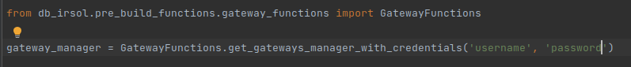

The first line of code imports the GatewayFunctions class, which contains all the pre-built functions that simplify the creation of the communication object.

The second line of code calls one of the pre-built functions, which allows an object for connecting to be created. In this case, the parameters to be passed to the function, in order for it to return the desired object, are the username and password of the user you wish to use.

That is all. With two lines of code, you have created an object that allows you to communicate and authenticate on the server.